EX NO:  **SOFTWARE PERSONAL MANAGEMENT SYSTEM**

USE CASE DIAGRAM:

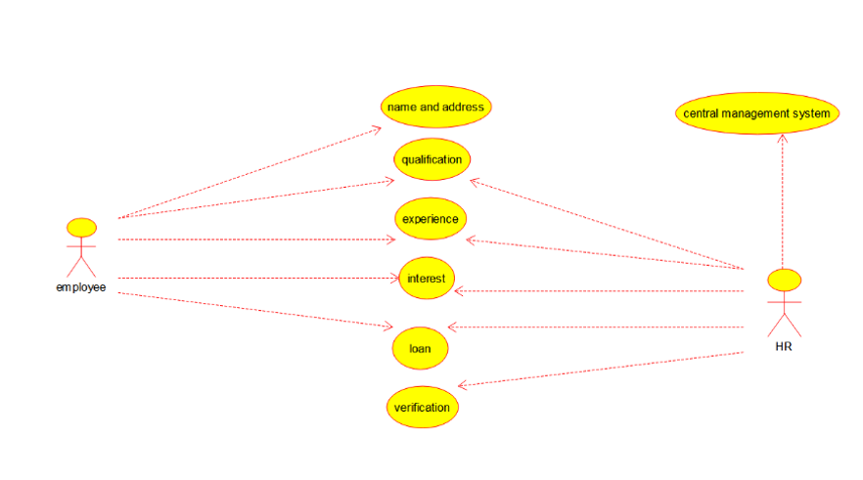

CLASS DIAGRAM: 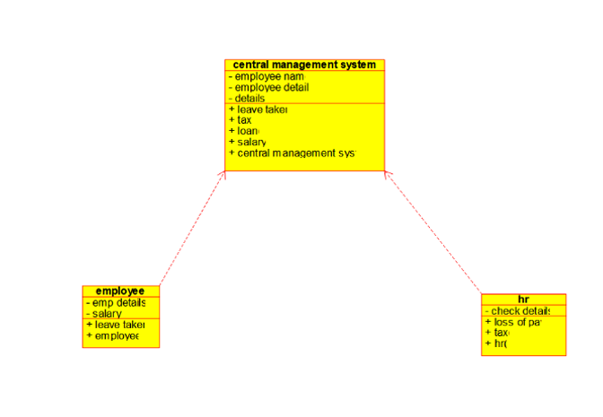

ACTIVITY DIAGRAM: 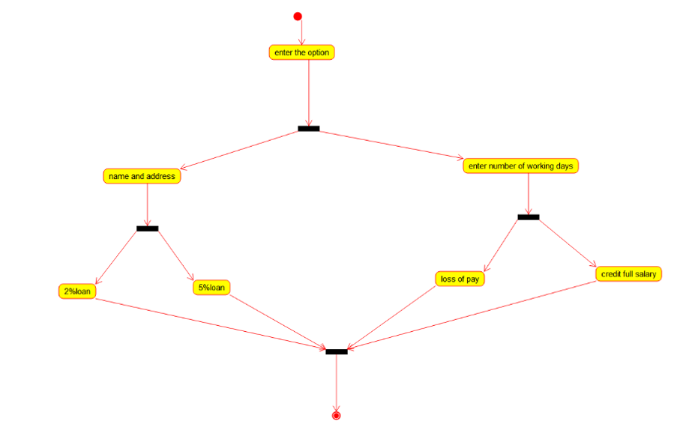

SEQUENCE DIAGRAM:

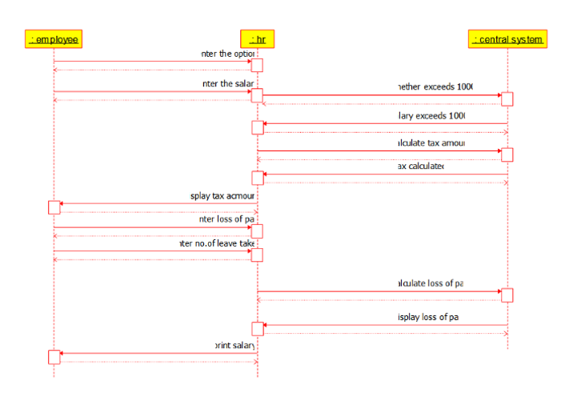

COLLABRATION DIAGRAM:

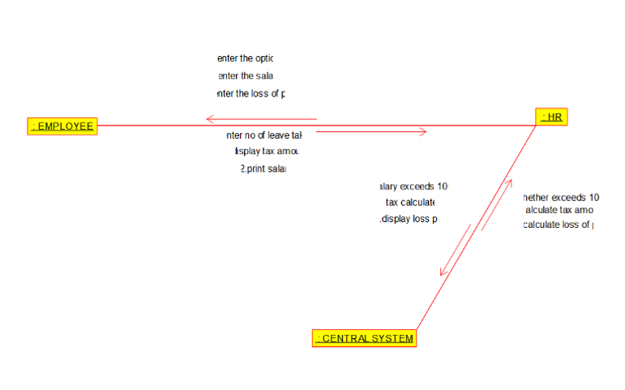

STATE DIAGRAM:



COMPONENT DIAGRAM:

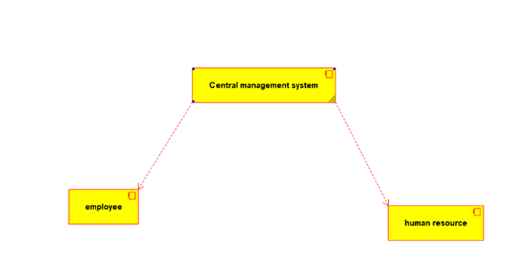

DEPLOYMENT DIAGRAM:

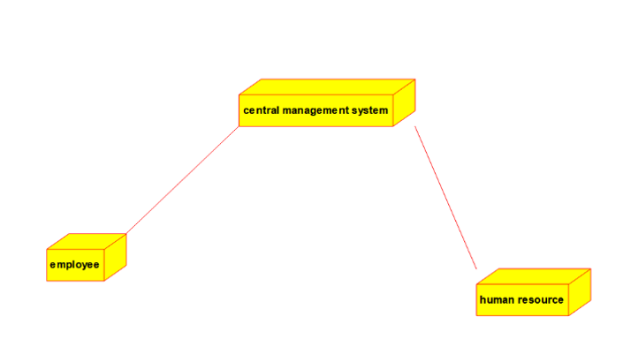

PROGRAM: **EMPLOYEE:**

Public class employee

{

Public integer employee details;

Public integer salary;

Public void leave taken()

{

}

Public void employee()

{

}

}

**HUMAN RESOURCES:**

Public class HR

{

Public integer check details;

Public void loss of pay()

{

}

Public void tax()

{

}

Public void HR()

{

}

}

**CENTRAL MANAGEMENT SYSTEM:**

Public class central management system

{

Public integer employee name;

Public integer employee no;

Public integer details;

Public void leave taken()

{

}

Public void tax()

{

}

Public void loan()

{

}

Public void salary()

{

}

}